**Problem Statement**

Improving time and cost efficiency related to supply chain management has been an admirable goal of Baptist Health. Yet, until now, focus has been on improving pre-existing process and procedures; however, now is the time for change.

Currently, the supply chain management at Baptist Health has a $55 million dollar distribution of commodity items ranging from Band-Aids to trash bags. Utilizing the current process for a large project of hundreds of items can take around 80 hours while a bid with fewer items may still take up to 20 hours. The current process involves: crunching data, writing an RFP (Request for Proposal), qualifying vendors, sending out RFP, answering questions during the open period, and gathering and calculating responses.

In addition to the copious amount of time the current process takes, it also allows for little competition between vendors to provide the best price. Currently there may be between 2-4 vendors competing for a Request for Proposal. Logically, this means the vendors have more power over the prices and discounts they provide. It’s the difference between buying a book at Barnes & Noble and buying the same book on Amazon or eBay. Online everyone is competing to provide the best price, however, land based establishments only have a few competitors and thus are able to charge higher prices. It seems doubtful as well as arduous that Baptist Health would deny all competing vendors bids and search for a better offering; and this gives the vendors’ power over price.

Ideally, Baptist Health needs a system to automate much of their current process while promoting competition between vendors allowing them to maximize opportunity costs. This system should also include a web-based application to streamline communication between vendors and Baptist Health as well as vendor competition. Overall, this supply chain management system will increase time and cost efficiency by speeding up the current process and increasing competition between vendors.

**Business Case**

A supply chain management system (SCMS) will undoubtedly benefit Baptist Health. Their current process (involving excel packets sent via email) causes large projects to take up to 80 hours to complete. A SCMS will reduce this time by allowing the system to automate aspects of the process that are currently left to employees. According to Baptist Health, the current process involves: crunching data, writing an RFP (Request for Proposal), qualifying vendors, sending out RFP, answering questions during the open period, and gathering and calculating responses. It can logically be concluded that the SCMS could: handle crunching data, provide a template for RFPs, pre-qualify vendors, have a contact support or FAQ (frequently asked questions) system, and automatically gather and send responses via the Web-application.

Rather than sending excel packets via email, the Web-based portion of the SCMS could streamline competition in ways only available to the internet; effectively, this would reduce costs for the following reasons: vendors across a wider geographical area can compete because the Web provides increased access, and vendors would be able to compete with each other more directly; possibly by being able to view key bits of information such as the price to beat and past order volume. Utilizing a larger supply pool of vendors and providing them with the grounds for direct competition would be an ideal scenario for Baptist Health. It’s pure and simple economics; greater supply leads to more competition and lower prices.

**Technical Feasibility: Can We Build It?**

In an effort to determine if this system can be successfully designed, developed, and installed by IT Professionals we must examine the following: familiarity with function area, familiarity with technology, project size, and compatibility.

Familiarity with the supply chain management’s functional area is vital to ensuring the SCMS will fulfill organizational needs. It becomes difficult to meet the users’ needs if the system analysts aren’t familiar with the business process that is taking place. On the other hand, the users may not understand the system or how it benefits the business process. These circumstances lead to wasted time and money for the organization if they can’t utilize the designed system.

Baptist Health has exceptional familiarity with functional area. Their team of three sourcing managers, a director, and two analysts has intimate familiarity with the current process in addition to a vision of their future system. Actively communicating with the Baptist Health team should ensure the system fulfills their needs.

When it comes to familiarity with technology the risk lies in the scope of users that will need to utilize this system. Since this technology will replace the current system there will be a learning curve for the current Supply Chain Management team. Additionally, vendors must be able to utilize the Web-based application that will allow them to compete for RFPs. Thus, the Web-based application must be user friendly and the IT group must devote time to training the systems’ users as well as possibly developing a Web-based tutorial for vendors.

The project size for a project of this magnitude is medium which poses average risks. The IT group consists of six members and the total time for proposal, design, and implementation should take less than one year. This system will replace the current process and must coordinate accessibility between vendors and Baptist Health. The Web-based portion of this system must be able to support up to multi-million dollar transactions, host thousands of items, and grant access to vendors and Baptist Health exclusively.

This system should experience improved compatibility with existing systems relative to the current process. This system allows for better organization efficiency due to automation of previously manual processes. Essentially, possible human error is replaced by computerized ‘perfection’.

**Economical Feasibility: Should We Build It?**

The economic feasibility of this project is determined by comparing the benefits in relation to the costs. Costs and benefits can be broken down into the following categories: development costs, operational costs, tangible benefits, and intangibles.

|  |  |
| --- | --- |
| **Development Costs** | **Operational Costs** |
| User Training- 8hr/ 1,000 |  |
| Development labor costs- 400,000 | System support- 5,000 |
| Hardware and Software- 2000 | Hardware Upgrade/Repairs- 1,000 |
| Misc Office Space and Equipment- 2000 | Total- 6,000 |
| Total – 405,000 |  |
|  |  |
|  |  |
| **Tangible Benefits** |
| Vendor fees paid for by vendors- 27,000/ year |
| Better Vendor Prices- 1,662,300/year |
| Total- 1,689,300/year |
|  |

Optional *

Development costs are concrete expenses incurred during the creation of the system and are typically one-time costs. Operational costs are those required to maintain the system and thus are seen as ongoing expenses. Tangible benefits are revenues and cost savings that come extrapolated from hard facts and numbers. Intangibles are based off intuition and logical inference rather than hard facts or numbers.

Due to Baptist Health being such a large and successful organization, the bulk of the costs will be operational costs. Operational team salaries, hosting the Web-based application on a cloud service, and utilizing a financial transaction service will incur the bulk of expenses. This is due to the sheer volume of items the application must host in addition to the large scale transactions it must process.

**Organizational Feasibility: If We Build It, Will They Come?**

To answer the question of organizational feasibility we must attempt to answer the question of how well the SCMS will be accepted and utilized by Baptist Health’s employees in addition to how well it fits into ongoing operations. Strategic alignment, the project champion, system users, and other stakeholders will make the determination of organizational feasibility.

Strategic alignment is determined by how well the new system will fit into the business strategy of the organization. Essentially, it asks the question of how this system will further organizational goals. In this case, a SCMS will further the business strategy of Baptist Health by increasing time and cost efficiency thus increasing profit.

The project champion, system users and other stakeholders are important considerations when implementing a new system. The project champion in this case is Cindy Gueltzow. Since Cindy came to the IT group for assistance with this problem she will likely be willing to support project design and implementation in addition to providing guidelines so that the end result is aligned with the current business process and strategy of Baptist Health Supply Chain. The system users will also be willing to support implementation since it levies the system with arduous tasks that are currently handled manually (such as data crunching). Essentially this system will make the users jobs easier to manage thus increasing time and cost efficiency for Baptist Health.

The primary ‘other stakeholders’ include the vendors. They must be willing to utilize the web-based application to conduct their business with Baptist Health. Since vendors currently utilize the same process as Baptist Health, this system should also increase the efficiency of their process. On the downside, they may forecast the competitive pricing environment this system has the potential to provide and may become resistant since competition will hurt their bottom line.

Incorporating the ideas and views of the system users is paramount to the success of this project. They must understand why this system should exist, how to use it effectively, and be able to provide input on system features. Routine meetings with the system users should alleviate most conflicts. Additionally, Baptist Health should contact its current vendors as well as other vendors ahead of time to prepare them for the implementation of the new system and process.

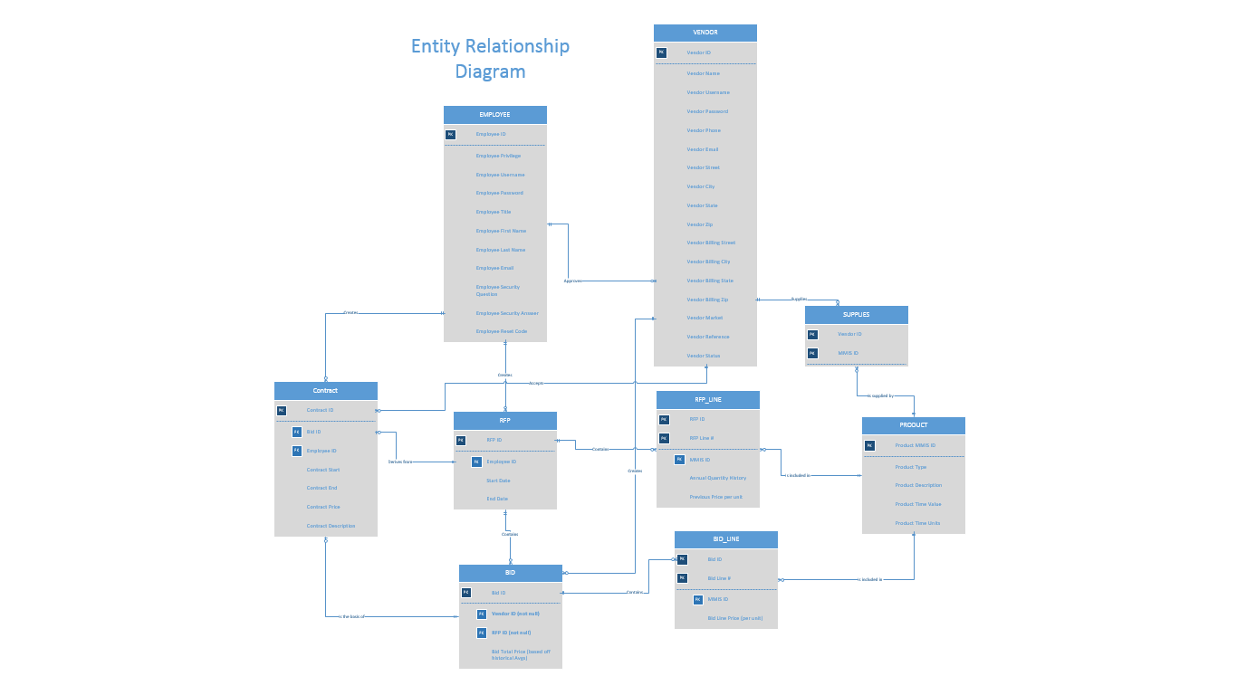

# Physical Architecture Design

The diagram below is known as the deployment diagram for the system. This diagram represents the proposed structure of the hardware and software components of the system.

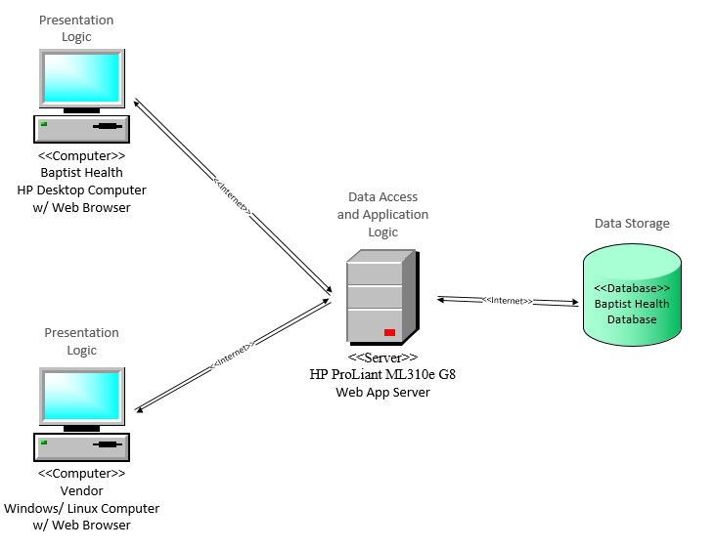

# Hardware

The Baptist Health and Vendor client computers will serve as an access point for users to interact with the system. Using these computers, users may communicate with the HP ProLiant Web App server to utilize system features that pertain to them. A majority of the tasks will require the server to retrieve or store data from the Baptist Health Database. The internet will serve as the communication medium between these hardware units.

# Software

The vendor and Baptist Health computers will contain the Presentation Logic software. This software will act as a bridge between the user and the system itself. The Web App Server will contain both the Data Access Logic and the Application Logic. The Data Access Logic will allow users to communicate with the Baptist Health Database. The Application Logic is the software that process and interprets data to send to both the Presentation Logic and Data Access Logic layers. The Baptist Health Database will contain the Data Logic. This software is what allows the database to store information in an organized manner that enables easier processing/retrieval of data.

# Architecture Specifications

The following diagram shows the minimum specifications for all the devices that will be used in the System.

**Traceability Matrix**

The use cases derive directly from the top-level system requirements. For each functional system requirement, a use case is created to provide the required functionality. In essence, the use cases were created in relation to the functional requirements.

|  |  |  |  |  |  |  |  |
| --- | --- | --- | --- | --- | --- | --- | --- |
| **Traceability Matrix** | | **Functional Requirements** | | | | | |
| **Use Case**  **Category** | **Use Cases** | **1 - Log in** | **2 - Manage RFP** | **3 - Manage Bid** | **4 - Register Vendor** | **5 - Reports** | **6- Contracts** |
| **1 - Log in** | **1.1 Log in** | X |  |  |  |  |  |
| **1.2 Reset Password** | X |  |  |  |  |  |
| **2 - Manage RFP** | **2.1 Create** |  | X |  |  |  |  |
| **2.2 Edit** |  | X |  |  |  |  |
| **2.3 Delete** |  | X |  |  |  |  |
| **3 - Manage Bid** | **3.1 Place** |  |  | X |  |  |  |
| **3.2 Edit** |  |  | X |  |  |  |
| **3.3 Cancel** |  |  | X |  |  |  |
| **3.4 View** |  |  | X |  |  |  |
| **3.5 Accept Bid** |  |  | X |  |  |  |
| **3.6 Reject Bid** |  |  | X |  |  |  |
| **4 - Register Vendor** | **4.1 Fill out Form** |  |  |  | X |  |  |
| **4.2 Pay Fee** |  |  |  | X |  |  |
| **4.3 Approve Vendor** |  |  |  | X |  |  |
| **4.4 Reject Vendor** |  |  |  | X |  |  |
| **4.5 Disqualify Vendor** |  |  |  | X |  |  |
| **5 - Reports** | **5.1 Generate Report** |  |  |  |  | X |  |
| **5.2 View Report** |  |  |  |  | X |  |
| **5.3 Download Report** |  |  |  |  | X |  |
| **6- Employee** | **6.1 Create Employee** | X |  |  |  |  |  |
| **6.2 Edit Employee** | X |  |  |  |  |  |
| **6.3 Delete Employee** | X |  |  |  |  |  |
| **7- Manage Contracts** | **7.1 Create Contract** |  |  |  |  |  | X |
| **7.2 Edit Contract** |  |  |  |  |  | X |
| **7.3 Delete Contract** |  |  |  |  |  | X |

**Initial Architecture Considerations**

**Design Viewpoint:**

The design diagram illustrates what the system must do to accomplish its goals. The Supply chain management (SCM) group and vendors must be able to access the ordering/bidding system. Security authorization should be required to access the system. This authorization could also determine the access level of the user.

The SCM group should be able to create RFPs that would:

1. Be saved to the RFP database

2. Optionally generate notifications (possibly through E-Mail, or dashboard) to applicable vendors.

Vendors should be able to register to the system and pay the credential fee that could recur automatically.

Vendors should then be able to log into the application and respond to RFPs and create bids/proposals. The SCM group could potentially accept proposals directly through the application causing any or all of following optional processes:

1. Generate payment to vendor

2. Generate payment report and send to RFP database

3. Initiate the payment process

**Realization Viewpoint:**

The realization diagram represents how the system performs its operations. The SCM group and vendors should be able to use their personal computers to access the web app server that should, in-turn, present them with the login portal. The web app server could store the data it generates into the system’s database server. Optionally, any web server currently utilized by BH and with enough free resources could be virtualized to host the web app under a different domain. Additionally, a single, server could be utilized and virtualized to act as a web app server and a database.

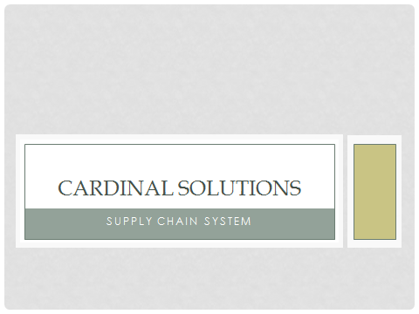  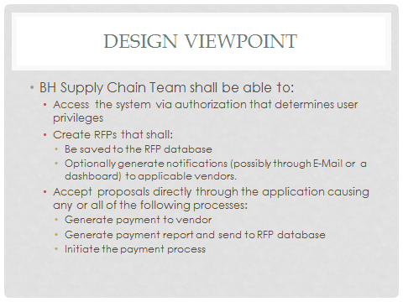 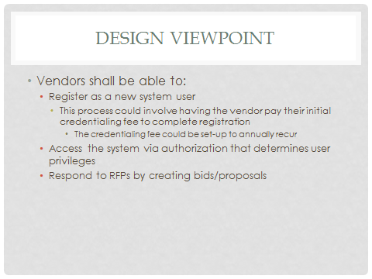 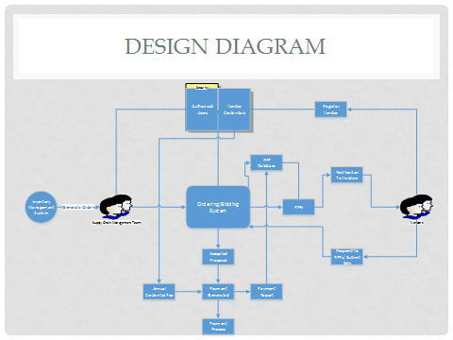 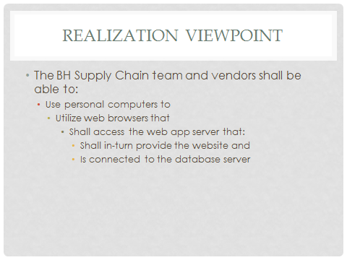 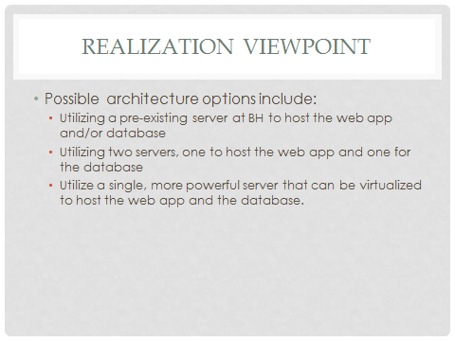 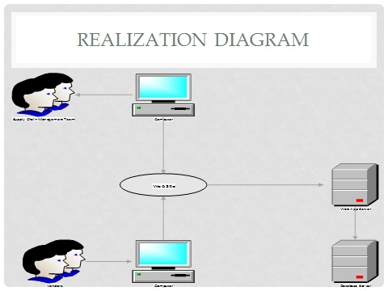

Jordan Shields

CIS 320-01

01-24-2014

The most common business processes are customer service and a search utility. Customer service includes the ability to contact the organization to resolve issues and disputes. Some organizations provide telephone numbers while others utilize email. The search utility, when effectively implemented, becomes the starting place of any process (that isn’t clearly labeled on the home page of the website) due to its ability to redirect clients to their desired process. Six of the ten organization’s websites feature (or advertise) their procurement process (which is their process/ability of obtaining goods for the purchaser that are currently unavailable). Half of the organizations in this analysis had a Login/User Registration process in addition to an inquiries process. The Login/User Registration process allows: prospective customers to apply for an account, returning customers to access information about their account and make purchases or purchase options. The inquiries process allows anyone to leave general feedback or ask general questions about the organization, or its products and services. The least common process, only featured/advertised by four of the ten organizations, is the order fulfillment process; this process entails the ability of the organization to offer multiple forms of order fulfillment (such as just-in-time inventory).

Three of the ten organizations utilized the web for all six of the processes; these organizations include: Cardinal Health, Intermountain Health Care, and Mckesson. These organizations should be heralded as representing the best practice for utilizing the web to support business processes. I make this claim because the websites of these organizations encompassed support or utilization of all the business processes analyzed in addition to ones not included. Utilizing websites for support of business processes increases efficiency in nearly all instances since it provides a platform for interchanging information at the quickest speeds.

Baptist health should consider including a Login/User registration process to allow new vendors or suppliers to quickly access information and expand the scope of the reverse auction. It will also allow validation to protect against unauthorized access to certain portions of the web site. Additionally, BH should also include different applications options that allow vendors to disclose if they provide order fulfillment and procurement options; although with a reverse auction procurement may not be necessary. A search bar is a great utility to direct clients to their desired location. A customer service process will cause clients to feel more comfortable transacting online since they have someone to contact if an issue should arise.

Jordan Shields

CIS 320-01

02/03/2014

**Credit Handling Services**

An integral part of conducting electronic commerce is handling credit transactions. Various companies offer their services in this regard to support credit processing and handling via the web in safe and secure environments; this service allows organizations to focus on their own specialties rather than creating potentially unsafe methods of handling and processing credit transactions that could result in identity theft or other forms of stolen information. The evaluation of credit handling services is conducted by comparing the following: fees, payment methods, gateway features, electronic commerce and integration, and client support.

**Fees**

Credit transaction services collect a combination of monthly and transaction fees to cover the costs of their services. Prices from the most competitive services range from $10-$35 per month with transaction fees of $0.10-$0.35 per transaction.

**Payment Methods**

These services may allow credit processing in the form of credit cards, debit cards and eChecks.

**Gateway Features**

Services that offer a virtual terminal offer an interface for processing credit cards via the internet. Secure socket layers is a security feature that is required for PCI approved security certification. CCV stands for card code verification and entails verifying the 3-4 digit code on the back of most credit cards. AVS, or address verification service, is the process of verifying that the given address matches the address attached to the card. A gateway said to be PCI DSS compliant means that it meets a set of required security standards for card data security.

**Electronic Commerce and Integration**

Most electronic commerce sites sell merchandise or services; thus having a credit handling service that is compatible with a shopping cart feature is typically desirable. Some credit services also allow automated recurring payments and generate invoices/receipts that are automatically sent to the respective buyer and sellers email address. Having an API or application programming interface allows the users of a credit services to add advanced and/or customized features to the process. A hosting service is optional and allows the credit service to host the user’s web site.

**Client Support**

Various features have been established to assist the user of a credit handling service; these features include: telephone support, FAQs/informational materials, email support, and live chat.

**Top Five Services**

The top five credit handling services to suit the needs of Baptist Health would be: GoEmerchant, Flagship Merchant Services, E-Commerce Exchange, Authorize.Net, and Chase Paymentech.

**GoEmerchant**

|  |  |  |  |  |
| --- | --- | --- | --- | --- |
| **Fees\*** | **Payment Methods** | **Gateway Features** | **eCommerce and integration** | **Client Support** |
| Monthly Fee: $14.95 | Credit Cards | Virtual Terminal | Shopping cart compatible | Telephone support |
| Transaction Fee: $0.10 | Debit Cards | SSL (Secure Sockets Layer) | Automated Recurring Payments | FAQs/ informational materials |
|  | eChecks | CCV (Card code verification) | Email invoice/ receipt | Email support |
|  |  | AVS (Address verification service) | API (Application programming interface) |  |
|  |  | PCI DSS Compliant Gateway (security standard) | Hosting Services |  |

**Flagship Merchant Services**

|  |  |  |  |  |
| --- | --- | --- | --- | --- |
| **Fees\*** | **Payment Methods** | **Gateway Features** | **eCommerce and integration** | **Client Support** |
| Monthly Fee: $16.95 | Credit Cards | Virtual Terminal | Shopping cart compatible | Telephone support |
| Transaction Fee: $0.19 | Debit Cards | SSL (Secure Sockets Layer) | Automated Recurring Payments | FAQs/ informational materials |
|  | eChecks | CCV (Card code verification) | Email invoice/ receipt | Email support |
|  |  | AVS (Address verification service) | API (Application programming interface) |  |
|  |  | PCI DSS Compliant Gateway (security standard) | Hosting Services |  |

**E-Commerce Exchange**

|  |  |  |  |  |
| --- | --- | --- | --- | --- |
| **Fees\*** | **Payment Methods** | **Gateway Features** | **eCommerce and integration** | **Client Support** |
| Monthly Fee: $10.00 | Credit Cards | Virtual Terminal | Shopping cart compatible | Telephone support |
| Transaction Fee: $0.16-$0.27 | Debit Cards | SSL (Secure Sockets Layer) | Automated Recurring Payments | FAQs/ informational materials |
|  | eChecks | CCV (Card code verification) | Email invoice/ receipt | Email support |
|  |  | AVS (Address verification service) | API (Application programming interface) |  |
|  |  | PCI DSS Compliant Gateway (security standard) | Hosting Services |  |

**Authorize.Net**

|  |  |  |  |  |
| --- | --- | --- | --- | --- |
| **Fees\*** | **Payment Methods** | **Gateway Features** | **eCommerce and integration** | **Client Support** |
| Monthly Fee: $20.00 | Credit Cards | Virtual Terminal | Shopping cart compatible | Telephone support |
| Transaction Fee: $0.10 | Debit Cards | SSL (Secure Sockets Layer) | Automated Recurring Payments | FAQs/ informational materials |
|  | eChecks | CCV (Card code verification) | Email invoice/ receipt | Email support |
|  |  | AVS (Address verification service) | API (Application programming interface) | Live Chat |
|  |  | PCI DSS Compliant Gateway (security standard) | Hosting Services |  |

**Chase Paymentech**

|  |  |  |  |  |
| --- | --- | --- | --- | --- |
| **Fees\*** | **Payment Methods** | **Gateway Features** | **eCommerce and integration** | **Client Support** |
| Monthly Fee: $17.50 | Credit Cards | Virtual Terminal | Shopping cart compatible | Telephone support |
| Transaction Fee: $0.24 | Debit Cards | SSL (Secure Sockets Layer) | Automated Recurring Payments | FAQs/ informational materials |
|  | eChecks | CCV (Card code verification) | Email invoice/ receipt | Email support |
|  |  | AVS (Address verification service) |  |  |
|  |  | PCI DSS Compliant Gateway (security standard) |  |  |

**Security and Privacy**

Each of these recommended services excel in the security and privacy areas by being PCI DSS compliant. The following are control objectives required for compliance: build and maintain a secure network, protect cardholder data, maintain a vulnerability management program, implement strong access control measures, regularly monitor and test networks, and maintain an information security policy.

**Recommendation**

The vision described by Cindy of BH entailed a system in which all transactions were handled and processed via the web-app portion of the system. Thus, the best service to suit the needs of Baptist health would be GoEmerchant which has the lowest fees per transactions and reasonable monthly charges; furthermore, they have all relative security standards in addition to compliance in the Visa USA’s Cardholder Information Security Program (CISP). On the downside, their preconfigured web stores seem basic relative to web 2.0 storefronts; however, since we are designing the site and are able to utilize their API this becomes irrelevant.